Process Hacker

## *By: Dylan Fox, Joachim Kikuni, and Kyle Muñoz*

Table of Contents

1. Introduction
2. Download Instructions
3. Main Uses
4. Processes
5. Services
6. Network
7. Disk
8. System Information
9. Tests
10. Overview
11. Conclusion

**Introduction:**

Process Hacker is a free software that allows you to see the complete list of all the processes running on your computer. It's a task manager similar to Task Manager on Windows, but improved and more powerful. Users have access to a panel of information about each running process and are able to customize, modify, and redistribute this open source software. This software allows users to manage processes, services, network connections, and disk information by using color coded tabs, graphs, and an easy-to-navigate user interface.

**How to Download:**

To download this software, visit: <https://processhacker.sourceforge.io/>. This link will show the screen below. Once here, you can easily click the download button that will take you to a new screen in which you can click to download the installer. After you’ve successfully finished installing, you should see the screen seen below in order to finish setting up Process Hacker.

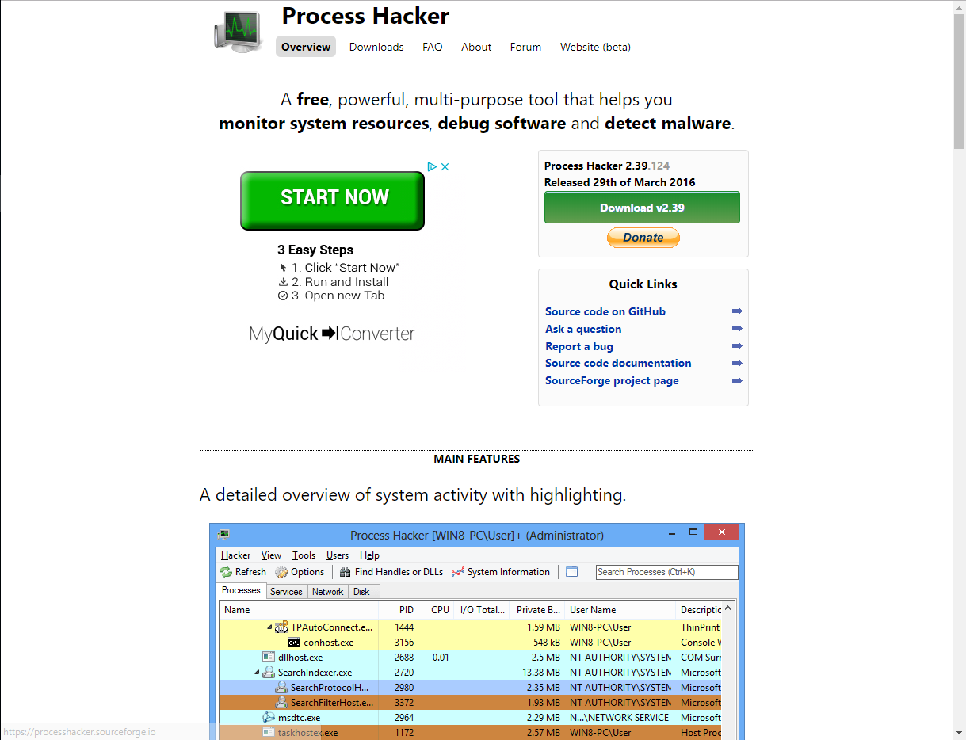

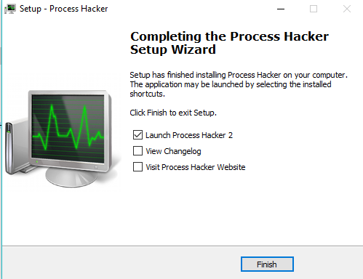

**Main Uses:**

After Process Hacker has been successfully installed, a list of processes will appear when the software is opened. From this screen, users are able to manage the Processes, Services, Network, and Disk. After you open it for the first time, it’s wise to reopen it as an Administrator in order to access all the benefits Process Hacker provides. These features make Process Hacker stand out from other process managing software because this software provides more information than most other managers. For example, Process Hacker provides more information about the disk and processes with network connections than the default Task Manager does on Windows computers. The main uses Process Hacker provides are management for processes, services, network, and disk.

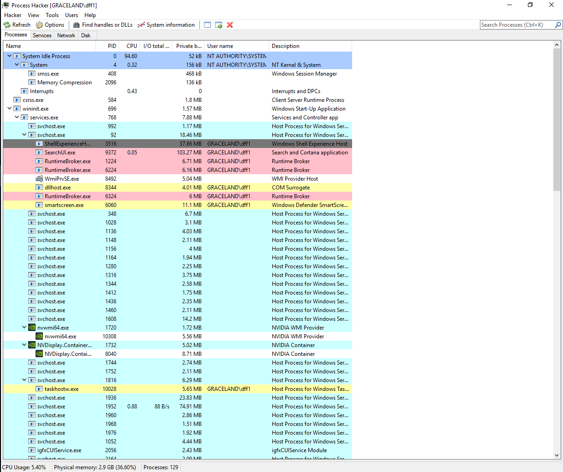

**Processes:**

The processes tab provides a lot of information of what is happening in the CPU. From this screen, users can read about each individual process that is running, a description about each process, the I/O, the number of processes, CPU usage, as well as statistics and performance of each process. These performance statistics and I/O are illustrated for each process by clicking on a process and hitting the enter key. This proves useful because it allows user to identify whether a process is taking up a large amount of the CPU.

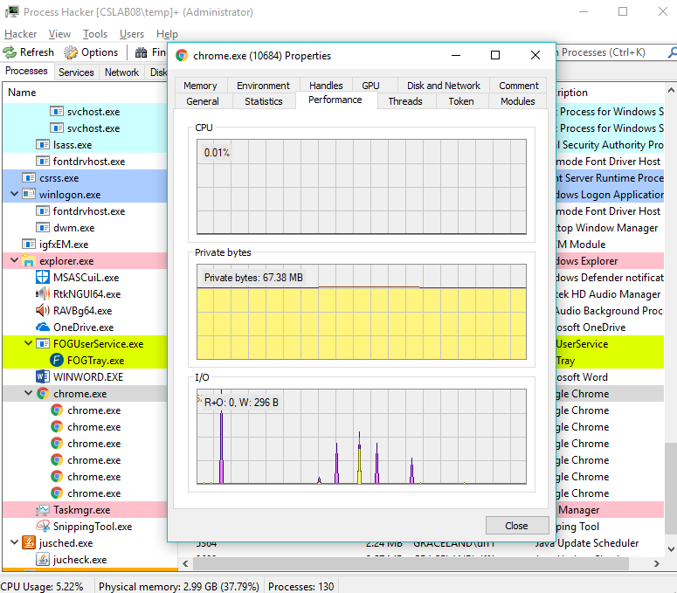

In addition to these statistics, users are able to terminate, suspend, or restart an individual process. This allows users to alter any process if needed. Another useful feature Process Hacker has is the ability to change the priority of a process. For example, users can give a process an I/O priority of “High”, instead of “Normal”, “Low”, or “Very Low”. This feature grants users access to change the how a process is handled in the CPU. Another key feature, Process Hacker provides each process with a specific highlight that allows users to identify what kind of process it is. Process Hacker enables users to learn much more about what is happening in their CPU and the ability to manage and customize it to their preference.

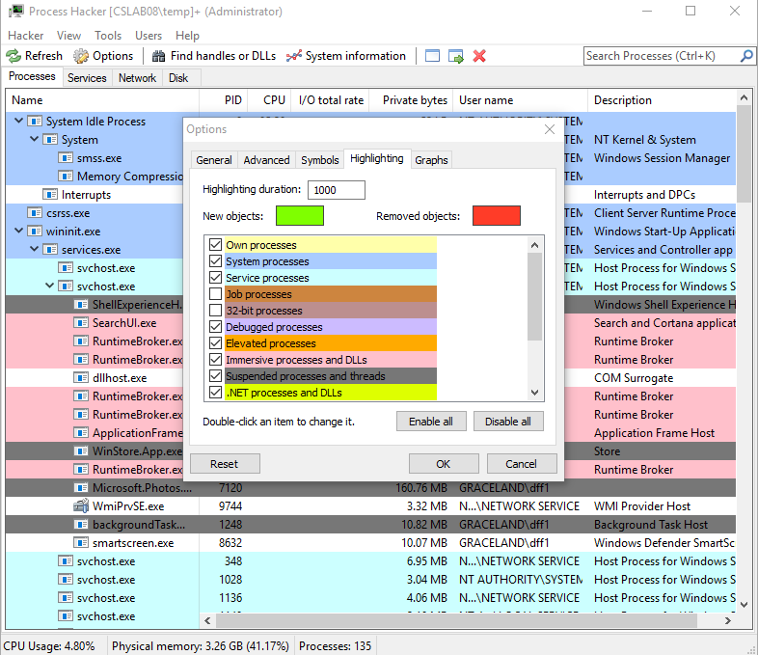

**Services:**

Now looking at the second tab, Services, users can identify what kinds of services are being run on the computer at the moment. This tab shows five different columns that provides more information on a specific service. The first provides the name, and the second provides the display name which is the application to what the service is attached to. The third column depicts the type of service, for example if it’s a drive or process. The fourth column determines whether the service is running or not. The last columns tells users when it’s programmed to run. For example, whether it’s programmed to start on demand, on boot, or if when the window is called.

 If you right click on a service, you will have an option to start or stop the service if the user is entered into administrative mode.

If you click on properties, you fall on the general window. The first thing you see on here is the explanation of what the service does, then below that  you have options to control the process. So you can edit their “type”, and “start time” so that they can start however/whenever you want. You can also check/change their location depending on the process. If you switch to the “Security” tab and check the “System Permissions” section. You see which permissions are granted to the running process. If you switch to the “recovery” window, you get to choose the actions that should happen if the service happened to fail starting. You have three actions. And four options. For example, you can choose not to take action when it first fails. Then when it fails for the second time, restart the service, and if it happens many times, restart the computer.

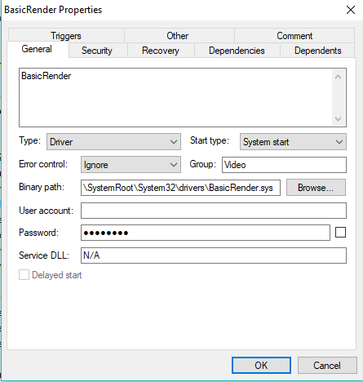

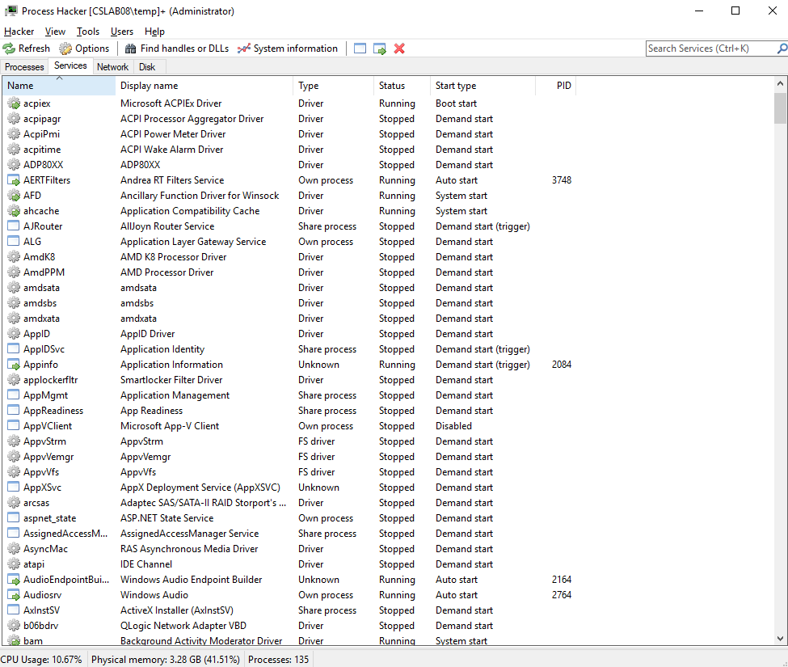**Network:**

In the Network tab, Process Hacker provides a list of processes that are running with a network connection. At the first glance, users can see each process’s local and remote address. In addition to the addresses, users can see the local and remote ports, the protocol, state, and owner of each process. Upon right-clicking a process, a menu comes up where users can “Go to process” which takes them to the corresponding process under the Processes tab. In addition, users can ping or traceroute a process when they right-click the process as well. This tab is especially useful because it allows for pinpointing specific network problems within processes. Unlike the Task Manager on Windows, Process Hacker goes into a deep description of each individual task, not just the overall network utilization.

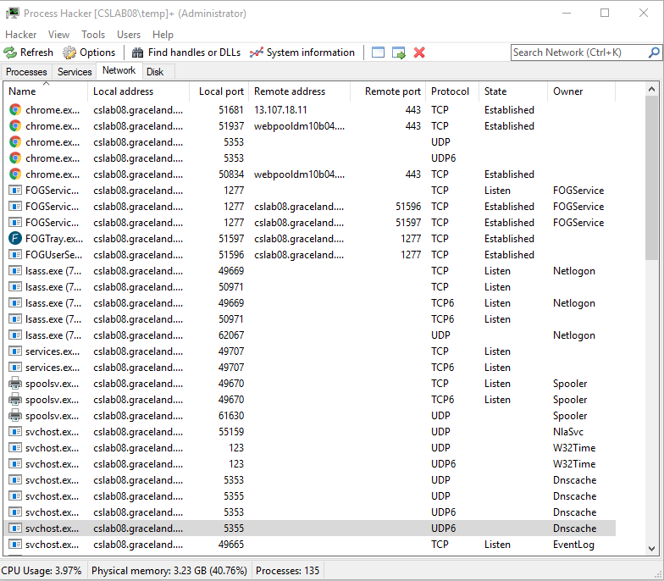

Shown above is what the screen looks like when the user selects the Network tab. Shown below is what the screen looks like when the user wants to ping/traceroute a process.

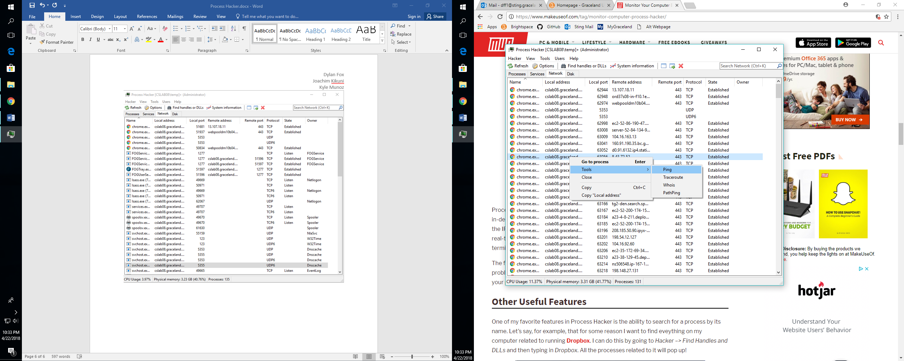

**Disk:**

Process Hacker also has a disk management windows. The disk windows is only available to those with administrative privileges. In the Disk window users can view what processes are using the disk as well as the time usage in the disk. Process Hacker displays read rate averages and write rate averages. This can allow users to take note of any task taking exceptional time in the disk, or even a hardware malfunction that might be causing one of the two to run exceptionally slow for every process. Furthermore, Process Hacker displays the total rate average which is a good column to look at for checking what task required more disk usage. Also, you can view the I/O priority of tasks with the app. Another beneficial thing you can do is right click to edit task properties and even can change I/O priority of task should you need to.

Another beneficial ability of the disk page of Process Hacker is that it shows response time in milliseconds. This may not seem beneficial to everyone, but if you are writing code or testing a program that you planned to be a quick program and it takes very long, it could reveal a heuristic error, where the code works, but not necessarily the most efficiently. The final benefit of this page is the ability to open to any of the programs file locations. Because of administrative privileges, you can open to file locations, which can be especially helpful if you are testing things.

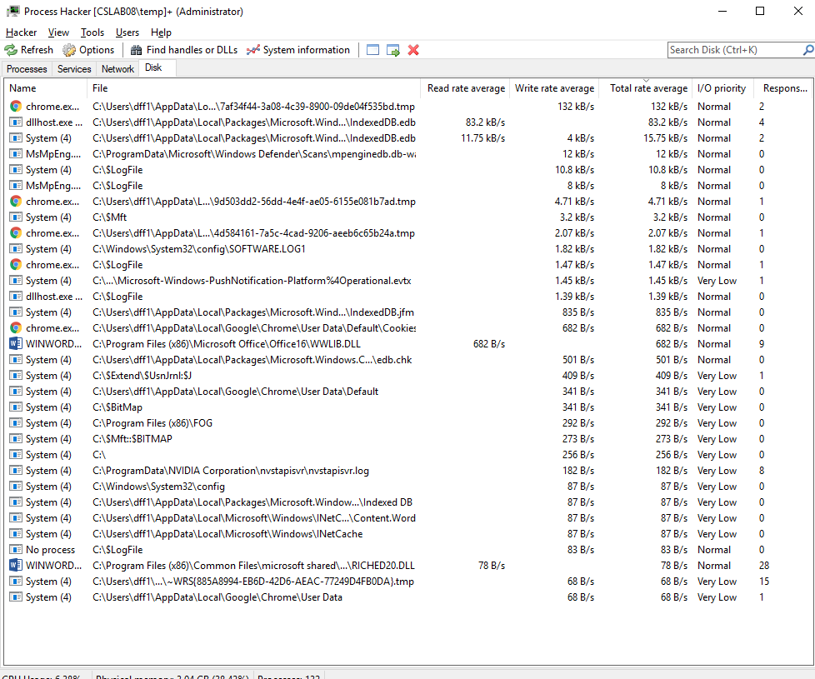

**System Information:**

One of the biggest advantages Process Hacker provides is the ability to visually see how the CPU, Memory, I/O, GPU, Disk, and Network are being used. By clicking the System Information button, users can see graphs for each of these components.

In each component, various statistics are given. In the CPU graph, users can see the utilization percentage, the speed in gigahertz, number of processes, threads, interrupts, and uptime amount. In the memory graph, Process Hacker shows graphs for commit charges and physical memory. The visualization of what’s happening in the CPU is very useful because it allows for easier debugging. Users can glance at this graph and discover whether there is a certain process taking up too much CPU time. In addition, by hovering over select parts of the graph, users can see which process is being ran and how much space and memory it is using. There are even options to display one graph per CPU in the computer. This allows users to pinpoint which CPU is being used more and what processes are being used in a specific CPU.

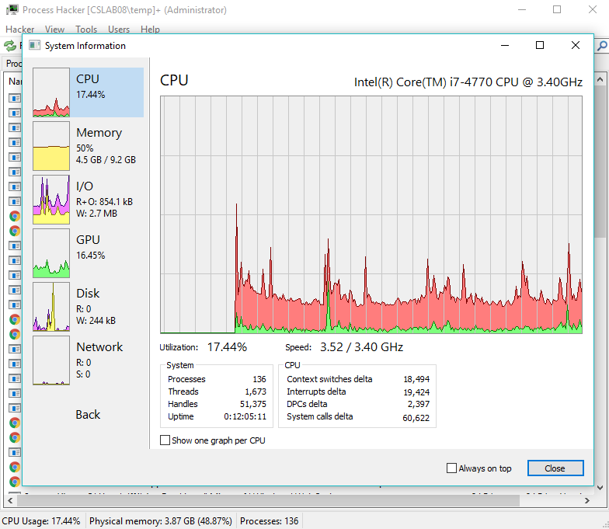

Looking at the memory graph now, users can identify how much memory is being used in the commit charge and physical memory. In addition, the total amount of memory in gigabytes used, the size of the working set, the number of page faults, and more can be seen below these graphs. These illustrations are beneficial because it becomes easy to identify if a large chunk of memory is being taken up. Users can also navigate here to see how much memory is being used in regard to the total amount of memory that is available.

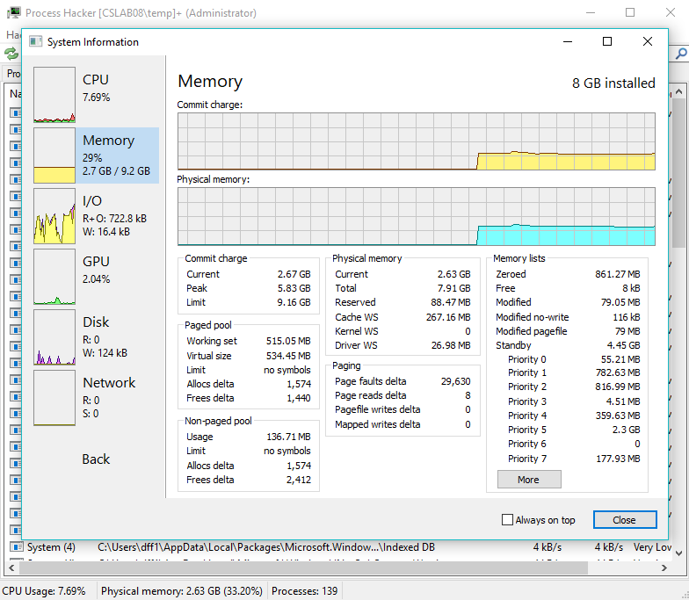

Transitioning to the I/O graph, this tab allows users to see the total number of reads, writes, and gigabytes used for the reads and writes. Hovering over a select part of the graph, users can see what specific process was being used at what time. Since Process Hacker allows for changing the priority of a specific process, the I/O graph will be able to illustrate how the CPU responds differently when a prioirty is altered. This is especially useful because the default Task Manager does not provide much information on the I/O of each process. Process Hacker’s addition of this information is beneficial because it allows for easier customization of the priority of different processes.

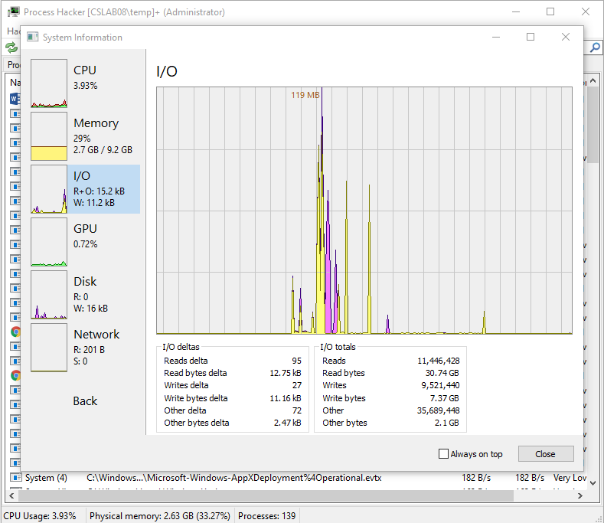

The next graph shown is the GPU. This graph illustrates the memory used for processing graphics on the computer. This is especially useful to look at when users are gaming on their computer. The GPU graph shows three different graph sections: one for the GPU, one for dedicated memory, and one for shared memory. Within these graphs, users can see the memory limit for both dedicated and shared memory, as well as the current usage of each memory. This proves to be a nice advantage for Process Hacker because graphics prove to take up a large amount of CPU time. Tasks such as film editing, gaming, videos, pictures, and graph design use a lot of graphics. Having the ability to monitor the GPU memory allows for those users to carefully watch over their usage.

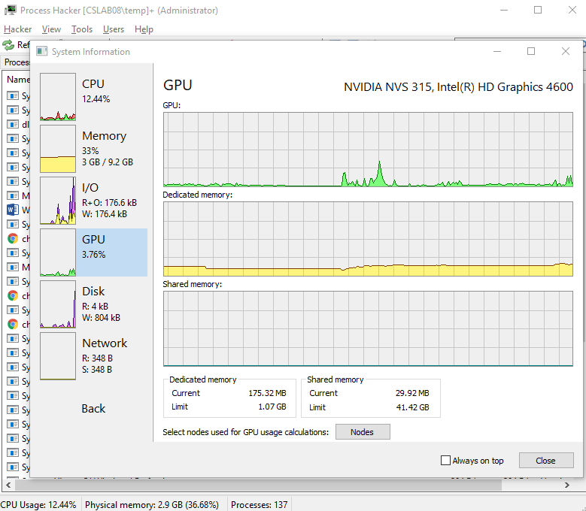

The fifth graph shows the input and output for the disk. The disk graph illustrates the number of reads and writes that have taken place at a specific moment in time. To see when a specific read or write has taken place, users can hover over the graph and see what process was being used and the memory size of that read or write. This allows users to view realtime data about the input and output of the disk and pinpoint specific faults in the disk management. This proves to be an advantage of Process Hacker because users do not have the ability to depict what process is being used at a specific moment in time on the graph on the Windows Task Manager and other process management systems.

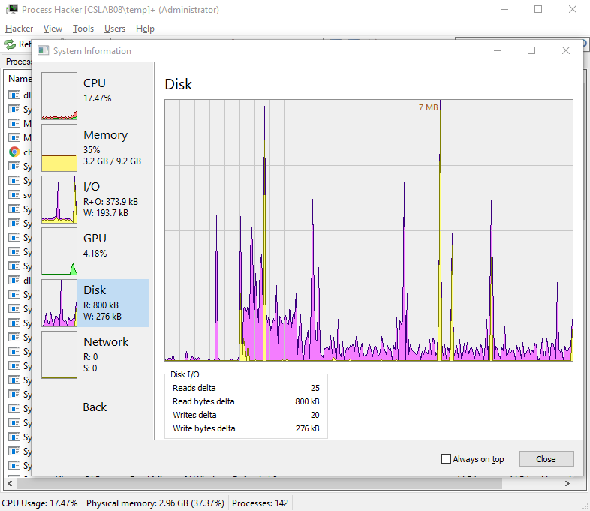

The final graph that Process Hacker provides for users is the Network graph. This graph records the amount of data that is sent to and received from networks. When users are not actively surfing the web or using a program that typically sends requests to the internet, this graph appears to have little data being graphed. In the next picture shown, the user went from not using the internet to opening many new tabs with search results. Individuals can see the different in the processes that connect to the network and do not. Also in this graph, users have the option to hover over a specific place in the graph to determine what process was being ran. For example, the user hovered over the yellow data in the graph below and discovered that the process “Chrome.exe” was producing that data. This network graph allows debugging capabilities to discover if a certain process is slowing down a computer because of the constant requests sent to a network. This is a feature that the Task Manager does not have, allowing easier dubugging for users using Process Hacker.

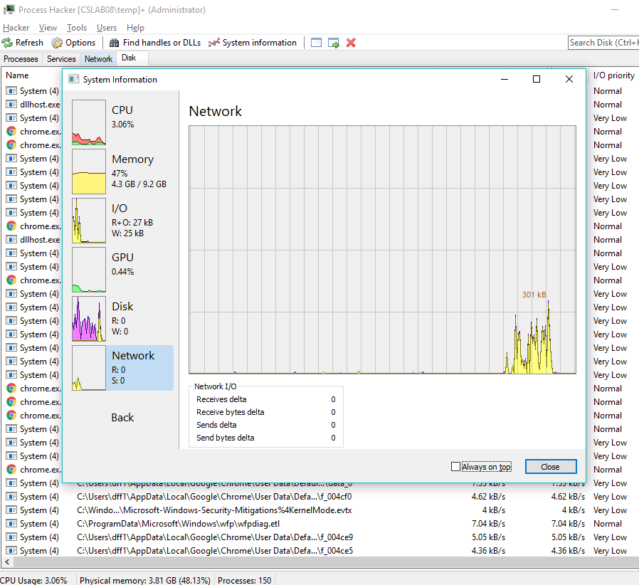

**Tests:**

To illustrate how Process Hacker is useful, multiple tests have been administered in order to test the CPU and watch what happens within the program. The first test conducted consisted of a script that opened 30 new tabs in the browser, Internet Explorer. Shown below is the starting stage of the CPU graph, with only two tabs open. The image shown after illustrates the spike in CPU usage when 30+ tabs were open and sending requests to the server. This test, while simple, provides an answer for many computer user’s slow computer problems. Many users open several tabs and never close them, plus open new software such as music or video streaming services. The combination of all these processes eat up a large amount of CPU, disk, and memory. With the knowledge that closing these programs and tabs when not being used can save space and time, more users will begin to close them and save their computer’s speed.

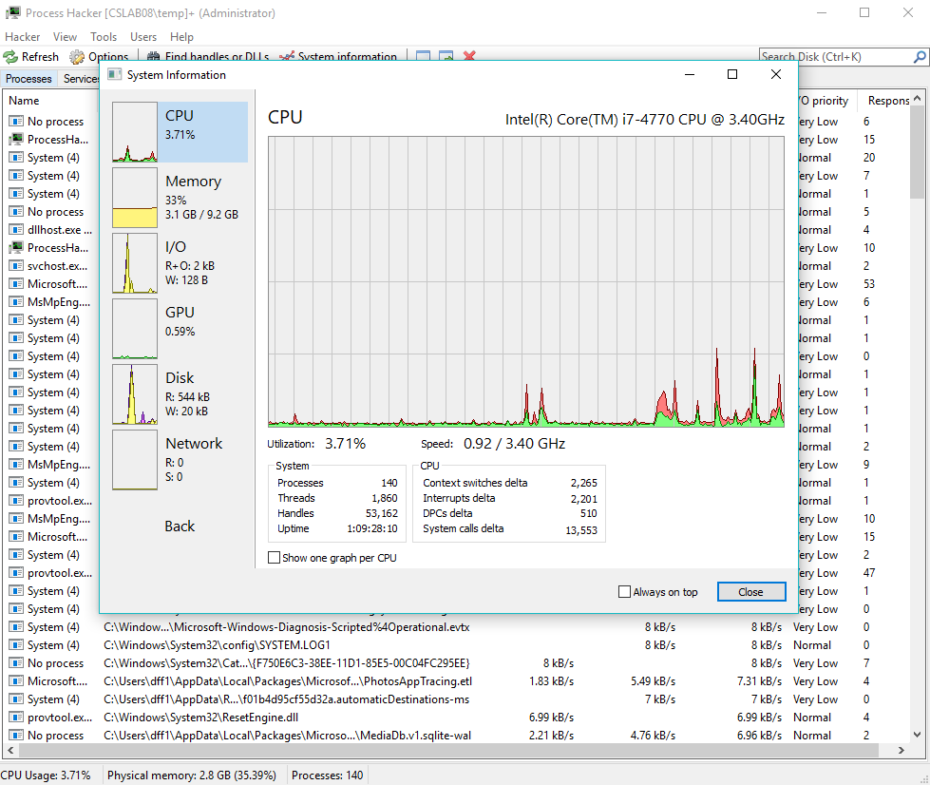

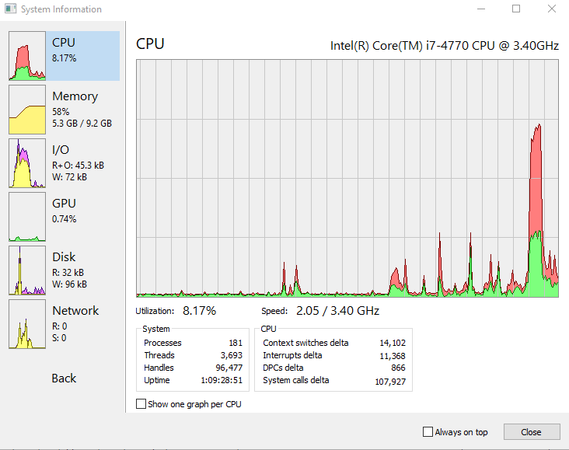

**Overview:**

At first glance, Process Hacker seems to be a normal process management program. But by diving deeper into all the features it provides, users can begin to see the real benefits of it. The first benefit many users notice are the highlights of processes and graphs. By color coding their processes, users can identify what type of a process it may be. Using this legend, users can learn more about a specific process and why it may be acting a certain way.

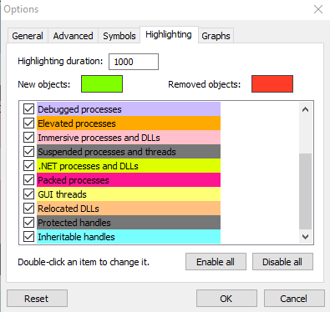

In addition to these highlights, the graphs Process Hacker provides prove to be very useful. While other task managers provide similar features, Process Hacker’s graphs depict much more information about each process and system. The ability to see data displayed for the CPU, memory, I/O, GPU, disk, and network outperform what many other managers provide. Plus, the ability to hover over certain parts of each graph and learn what process was used at a certain time allows for quick and easy debuggng of processes.

Another advantage Process Hacker provides is the ability to customize the program itself and different processes to a certain degree. For example, users can choose different colors to highlight certain processes to their liking, set different priorities for processes, change the opacity percentage of the user interface, as well as many other different options that Process Hacker provides. This is an advantage in regards to other process managements because many others do not provide as many customization options. For example, the Windows Task Manager does not offer nearly as many options as Process Hacker does. To illustrate this, below is an example of Process Hacker with the opacity turned down with more options shown on the user interface.

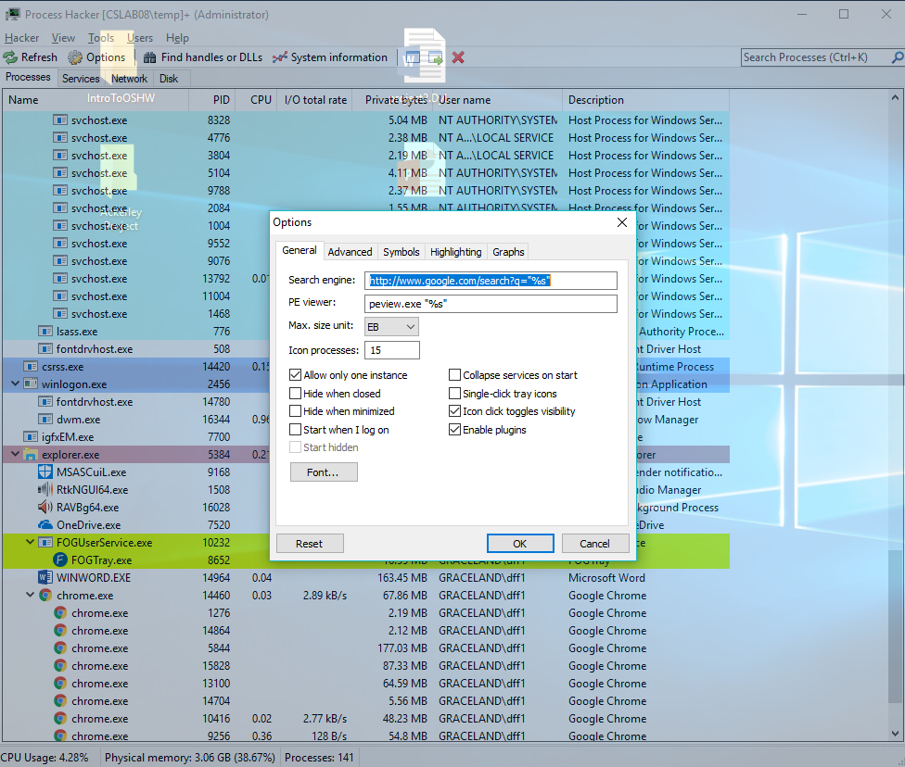

The third major advantage Process Hacker is known for is the amount of debugging it allows for. The ability to see the corresponding processes and services with the network and disk lets users pinpoint specific bugs within the CPU. In addition, the multiple graphs for the CPU, memory, I/O, GPU, disk, and network provides easy and quick debugging by glancing at each of these graphs. For example, it’s easy to look at one of these graphs and determine if there is a bug or a certain process misbehaving. The ability to hover over different parts of time within a graph and see which specific process is running is a unqiue feature that other process managements don’t have. While other process managements provide visual aids to help understand how the CPU is running, they do not provide an easy way to depict what process is responsible for what output, like Task Manager.

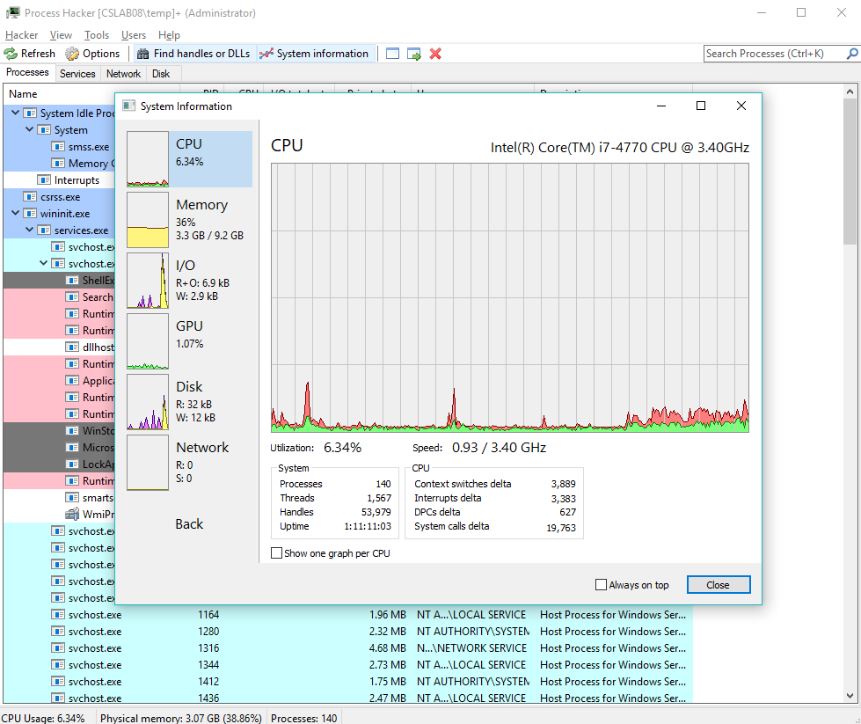

The fourth and most important advantage is the fact that Process Hacker is an open source software. This means that anyone can download and alter the code behind the software and redistribute. This ties into the ability to customize to the user’s preference. Since it’s open source, users can take the code and chance anything about it to their liking. This is a huge advantage for Process Hacker because its competitors are not open source. Task managers such as, Process Explorer and the Windows Task Manager do not have their code shared with the public. This means more users will be interested in Process Hacker because it’ll allow them to make changes to whatever they so choose.

**Conclusion:**

Process Hacker provides many different features that allow it to rise above its competitors. For example, the use of graphs and highlights allow for quick groupings of processes, the ability to customize it to a user’s preference, quick debugging, and the ability to alter the code since it’s open source. These features allow for Process Hacker to offer many different options in order to efficiently monitor the CPU on a computer. When compared with other process management systems, Process Hacker tends to have a more complete and thorough analysis of the processes, services, network connections, and disk management.